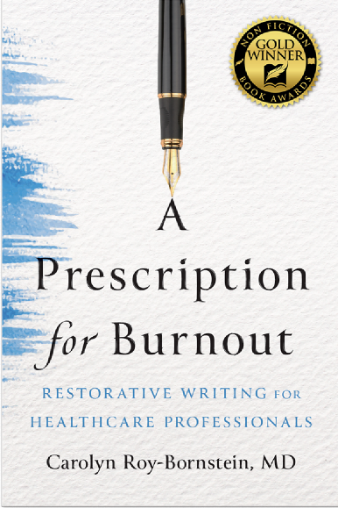
About the author
Carolyn Roy-Bornstein is a board-certified pediatrician and the Writer-in-Residence at a large urban family medicine residency program where she teaches narrative medicine to physicians in training as they explore their relationships with patients and colleagues and their journeys toward becoming doctors. Her essays and short stories have appeared in The New York Times, The Washington Post, The Boston Globe, Poets & Writers, JAMA, The Writer, The Examined Life, and many other venues. Her flash fiction won third place in the Writer's Digest Short Short Story competition. She is the author of four books, most recently A Prescription for Burnout: Restorative Writing for Healthcare professionals, published by Johns Hopkins University Press.
About the Book
Physicians, nurses, and other healthcare professionals are leaving medicine in record numbers due in large part to exhaustion, disillusionment, and a profound loss of joy in their work. In A Prescription for Burnout: Restorative Writing for Healthcare Professionals, Carolyn Roy-Bornstein, MD, offers a powerful, science-backed remedy to burnout in the healthcare field: reflective writing. This guide is a structured, compassionate companion for those who want to stay in the profession they once loved and renew their sense of purpose.
The book is organized around the three dimensions of burnout identified by psychologist Christina Maslach―emotional exhaustion, cynicism, and a perceived lack of efficacy. Each chapter introduces a focused writing practice to help clinicians reconnect with their values, strengthen empathy, and rediscover meaning in their work. Dr. Roy-Bornstein brings more than three decades of experience as a nurse, pediatrician, and narrative medicine educator to this deeply personal and practical work. She knows firsthand how writing can transform grief, trauma, and professional disillusionment into clarity, self-awareness, and healing.
These evidence-based and insightful exercises are designed to be brief yet sustaining antidotes to the pace and pressures of modern healthcare. Whether used privately or in groups, in early training or late-career reflection, A Prescription for Burnout offers clinicians not just strategies for surviving the system but tools to reclaim their voice―and their vocation.

Registration Code:


